


Project Navodaya

ABAP Technical Specification

Document Information

Document Number
Title | RAP Application for YRMR169
Document Purpose | Optimization of report YRMR169
Key Words
Document Status | Final
Contact for Enquiries | SARFRAZ

Document Change Control :
Release | Description | Created by | Date | Reviewed by | Date | Approved by | Date
01 | RAP Application for YRMR169 | SARFRAZ | 16-06-2025

Header
Area (R/3Module): | MM |  |  |  |  | Date: |  | 17-01-2025
Requested by: | GAIL MM team
Title: | RAP Application for YRMR169
Short description: | Optimization of report YRMR169
Functional Developer: | Manoj Kumar (SAP) |  |  |  |  |  | Phone: | +91
Technical Developer: | Sayyad Sarfraz Ali |  |  |  |  |  | Phone: | +91 8827833896
Program name:
Type: | Change Request Development Request(Creation) Rework
Program type: (select the check box) | Conversion Batch Interface Online Interface Report  Form Enhancement Extension Dialog  Modification Unknown Others BAPI  ALE/ IDOC Application Development
Priority: | Very High High Medium Low
Complexity: | Very High High Medium Low
Specify known SAP functionality: |  | <Specify the related SAP transactions>
Cross Reference Documentation:
Only for Interfaces:  Type of interface:  Direction of interface:  Frequency: |  |  |  | Real-Time Batch  Inbound Outbound Both  Daily Weekly Monthly  Biweekly Other:
Only for Reports:  1. The report will be created via:  2. Requested characteristics: |  |  | Standard Report  Report Painter Report Writer ABAP Query  ABAP Program Info System  Drill-down Pushbuttons Sort  Entry files Others: _____________________
Generic question:  1. Impact of not creating the program: |  |  | legal requirements will not be fulfilled  lack of information required for the business  lose functionality compared to the old system  others: could have duplicate data entered into the system_
Development labor estimate:
Are there any alternatives in the standard system: |  |  |  |  | Yes No
Describe the alternative found:
Reason why this alternative was not acceptable: |  |  |  |  | Performance problems Complexity  Others: The transaction to initiate

Technical Specification
3.1. Technical Report Created:

Root CDS: YRMR169_MM_PO_1
Entity Set: YRMR169_MM_PO_1
Service Defination : YRMR169_MM_PO_SD
Service Binding : YRMR169_MM_PO_SB

Development Overview

Sr. No | Program Name | Transaction Code | Transport Request No | Dependency/ TR Sequence
1 | YRMR169_MM_PO_REPORT | YRMR169 | SBRK903246

Development Details

Code
Screen:
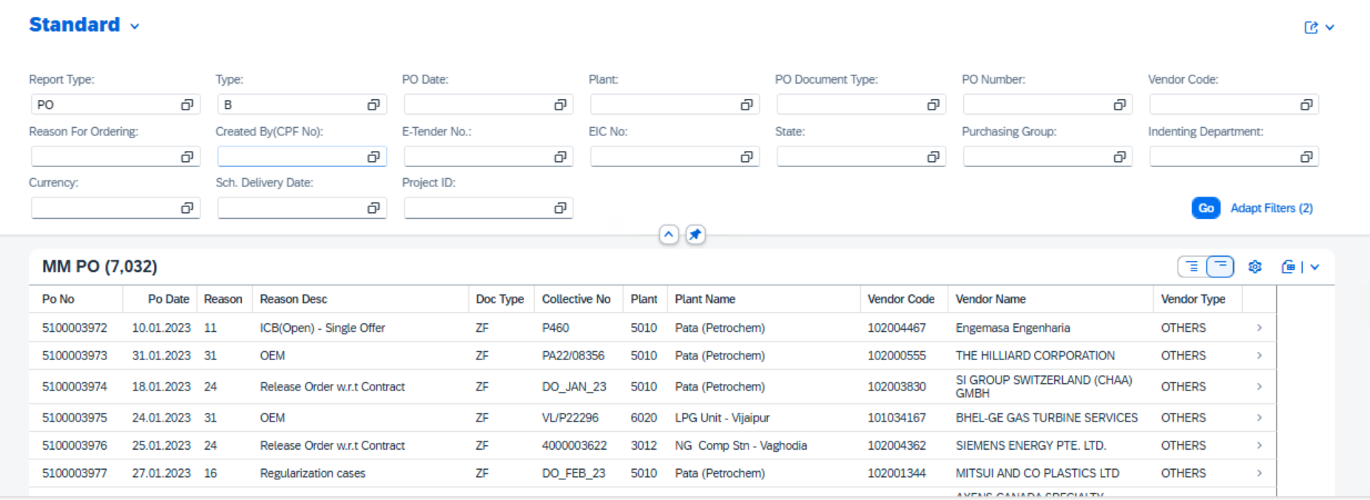

Logic:

1. CDS: YRMR169_BANK_NAME
This CDS view fetches the Purchasing Document Number from table TLCT_ORDER, MAX (Name 1 of organization from table) BUT000, MAX (Term End) from table VTBFHAZU, Credit Amount Currency, MAX (Credit Amount), MAX (Bank Guarantee Number) from table TLCT_ACTIVITY matching records from table VTBFHAZU, VTBFHA, TLCT_ACTIVITY based on Company Code and Financial Transaction, also joining table BUT000 for all records based on VTBFHA-Business Partner Number. where VTBFHAZU-Active Status of Transaction or Activity is equal to ‘0’. Group by Purchasing Document Number, Credit Amount Currency is used to avoid duplicate entries.
2. CDS: YRMR169_LEWED
This CDS view fetches the Purchasing Document Number from EKKO, MAX (Latest Possible Goods Receipt) from EKPO. Join EKPO based on Purchasing Document Number. Group by Purchasing Document Number is used to avoid duplicate entries.
- CDS: YRMR169_BASIC_1
This CDS view fetches the Purchasing Document Number from EKKO and Net Order Value in PO Currency from EKPO by joining EKPO based on Purchasing Document Number where EKPO- Purchasing Document Number LIKE in [ ‘51%’, ‘52%’, ‘53%’, ‘56%’, ‘57%’, ‘58%’, ’59%’, ‘61%’, ‘63%’, ‘71%’, ‘72%’] and Deletion Indicator in Purchasing Document is initial and EKKO-Purchasing Document Category is ‘F’ and EKKO-Purchasing Document Date is greater than parameter p_dat_from and lesser than parameter p_dat_to and EKKO- Category of Incompleteness is initial. Group by Purchasing Document Number is used to avoid duplicate entries.
- CDS: YRMR169_EBAN
This CDS view fetches the Purchasing Document Number from EKKO, Item Number of Purchasing Document, Purchase Requisition Number, Item number of purchase requisition from EKPO, Name of Person Responsible for Creating the Object, Requisition (request) date, waers, Price in Purchase Requisition from EBAN by joining table EKPO based on Purchasing Document Number and EBAN based on Purchase Requisition Number, Item number of purchase requisition where Purchase Requisition Number should not be null, Item number of purchase requisition should not be 0, EKPO- Purchasing Document Number LIKE in [ ‘51%’, ‘52%’, ‘53%’, ‘56%’, ‘57%’, ‘58%’, ’59%’, ‘61%’, ‘63%’, ‘71%’, ‘72%’] and Deletion Indicator in Purchasing Document is initial, EKKO-Purchasing Document Category is ‘F’, EKKO- Category of Incompleteness is initial.

- Root CDS: YRMR169_MM_PO_1
This CDS view fetches the Purchasing Document Number, Purchasing Document Date, Purchasing Document Type, Supplier's Account Number, Collective Number, User of person who created a purchasing document, Currency Key, Exchange Rate, Miscellaneous delivery number, External bill of lading, Tax destination, Pipeline trip number (external), Alternate origin, Alternate destination, Truck number, Purchasing Group from EKKO, Plant, Reason for Ordering, Purchase Order Unit of Measure, Purchase Order Quantity, Requirement Tracking Number from EKPO, Name of Person Responsible for Creating the Object from CDS view YRMR169_EBAN, and other fields joining table EKPO on Purchasing Document Number, YRMR169_EBAN, t001w, yrma_vendor_type, yrma_nivida_po, tbsgt, lfa1, t005t, t024, yrma_cpf_name_dg, pa0001, T001K, YRMR169_basic_1, EKET where EKPO- Purchasing Document Number LIKE in [ ‘51%’, ‘52%’, ‘53%’, ‘56%’, ‘57%’, ‘58%’, ’59%’, ‘61%’, ‘63%’, ‘71%’, ‘72%’] and Deletion Indicator in Purchasing Document is initial and Short Text equal to ‘AUTOMATIC GENERATION - FREIGHT SERVICE' and EKKO-Purchasing Document Category is ‘F’ and EKKO-Purchasing Document Date is greater than or equal to ‘20230101’ and lesser than equal to ‘20233112’ and EKKO- Category of Incompleteness is initial
- Metadata:
Once the data is fetched from the CDS, a metadata is created to define the UI of the fiori app.
7. Service Definition Exposure:
Once the metadata is defined for the CDS view entity elements, it is exposed through a service definition. This step makes the data accessible for external systems to consume.
8. Service Binding and Maintenance:
The service definition is bound and maintained. This ensures that the service is available to the desired applications and users.
9. Fiori Tile Creation and Role Assignment
A Fiori tile is created to display the data exposed by the service. Additionally, roles are assigned to ensure that only authorized users can access and view this tile.

Table Creation
N/A

Security /Authorization
N/A

User Exit
N/A

Transaction / Batch Job that will access enhancement
N/A

Anticipated performance Issues (if any)
N/A

Registration
N/A

Assumptions/ Notes

Unit Test Case
Screenshot for testing

- Report Screen:

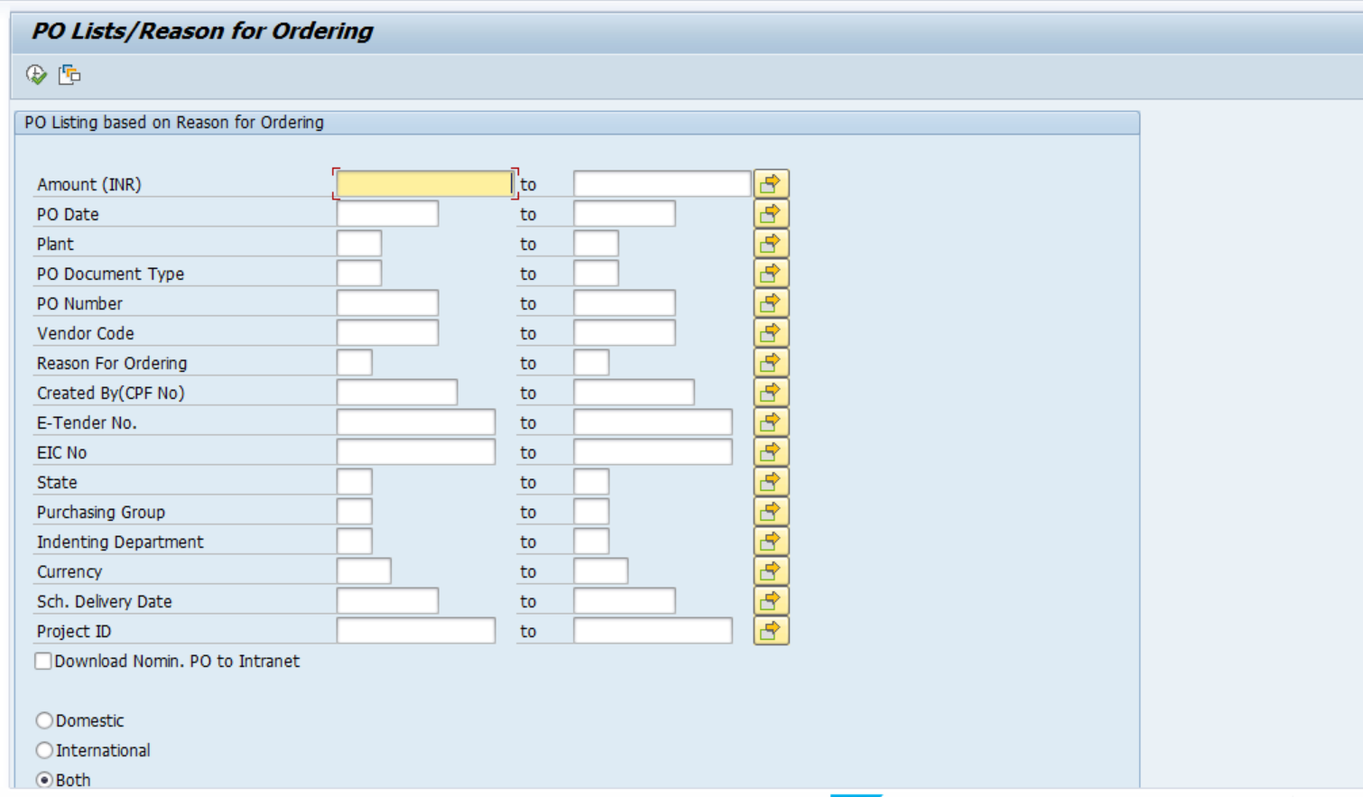
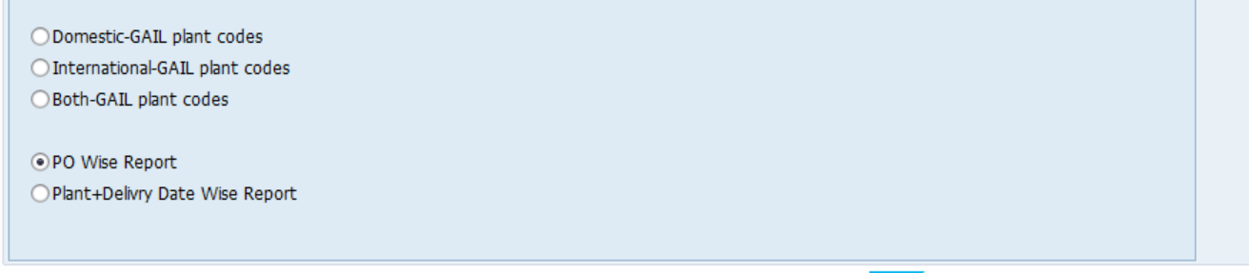
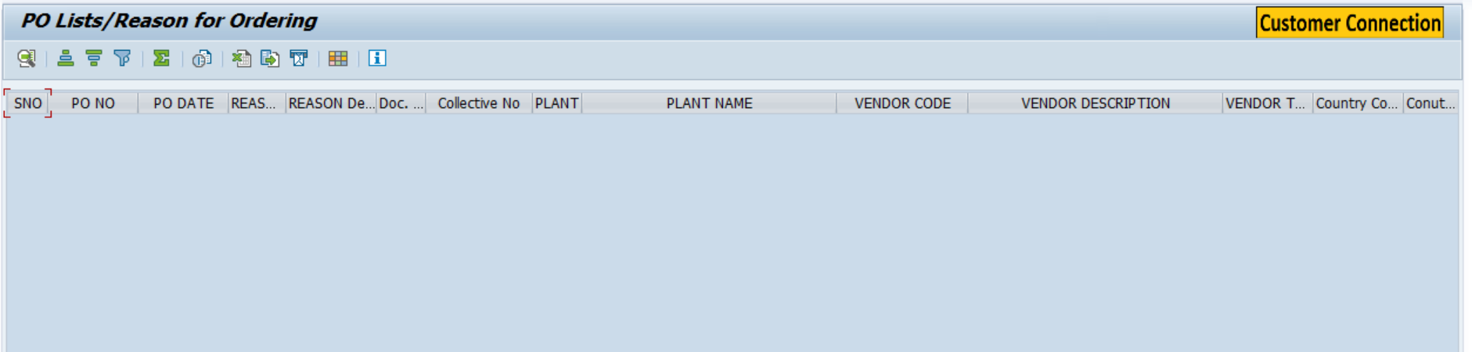
- Fiori Screen:

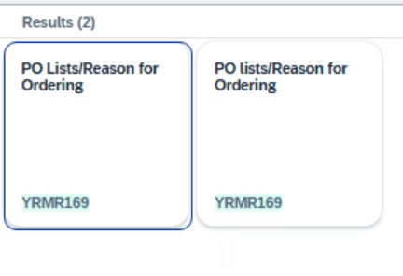

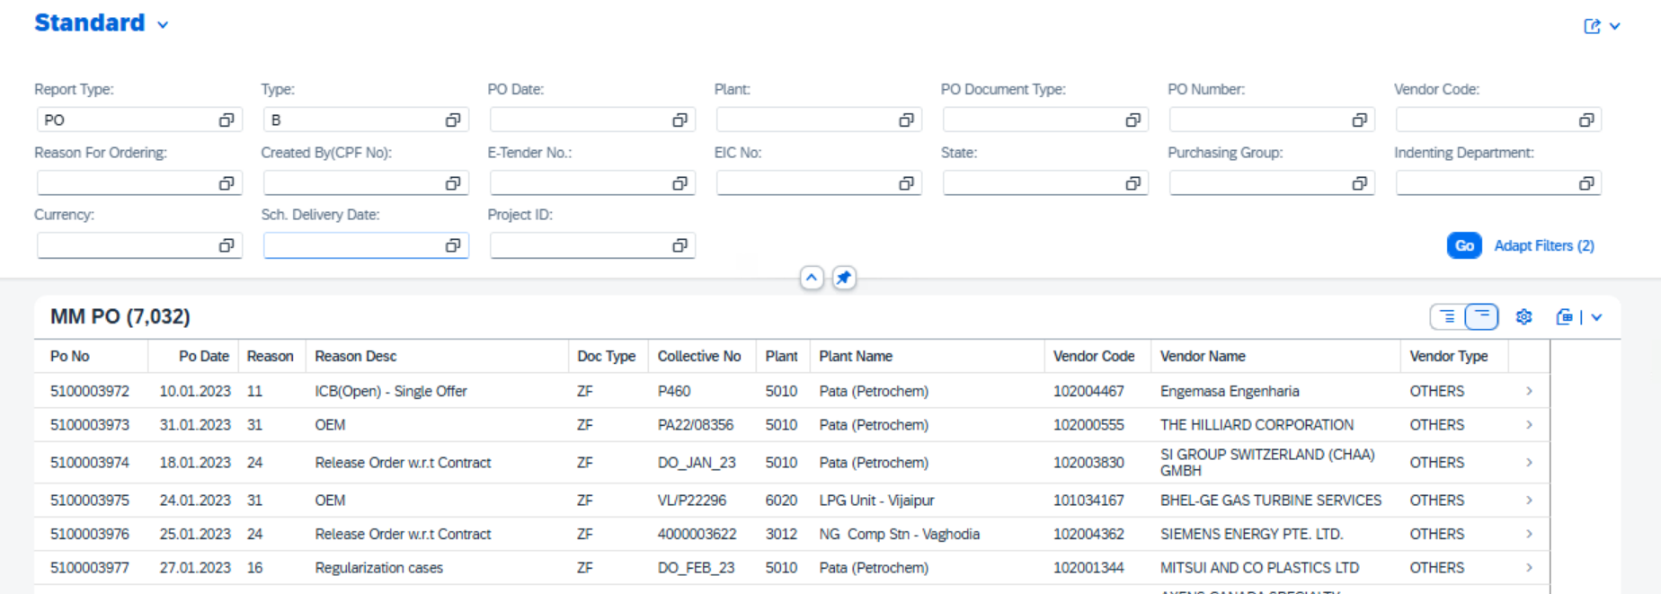

Technical Spec Original Sign Off:

Names and Signatures:

_____________SARFRAZ_______________________________ Date: ___18/06/2025________

____________________________________________________ Date: _____________

____________________________________________________ Date: _____________

____________________________________________________ Date: _____________

Modifications
< Description of Modification if any>
<Support document of the modification like screen shot of email received>

